
SecurePIN 100 _____
Selling Sheet
Overview

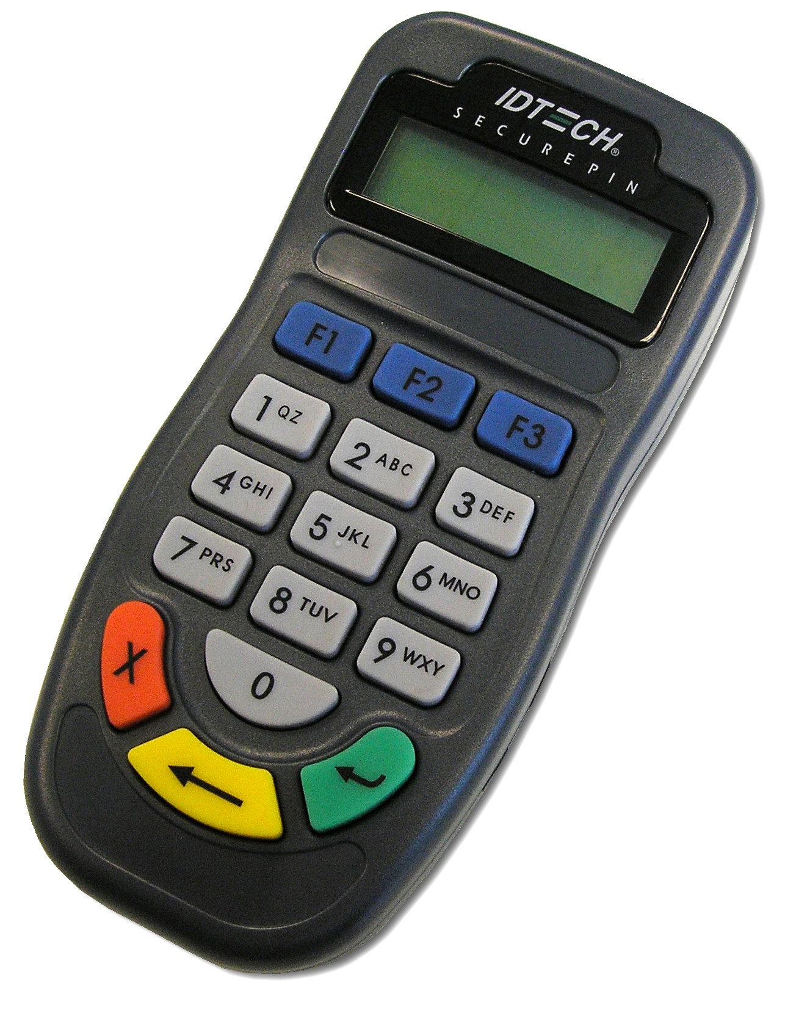
On behalf of ID TECH, we are pleased to introduce our newest member in the POS system product family – SecurePIN 100

The SecurePIN 100 is a PCI (Payment Card Industry) certified hand held PIN (Personal Identification Number) Entry Device that has one of the smallest footprints among most of the major manufacturers in the PED (PIN Entry Device) industry. The SecurePIN is designed to satisfy the significant increase of debit, EBT, and any other PIN-required transactions with guaranteed highest security to protect user’s PIN number. Private labeling is possible with minimum order of 1,000 parts.

Feature Bullet Points

• Compact & ergonomic design for space saving and users’ convenience
• PCI certified to provide the highest security for customer’s PIN-based transactions
• Tamper-detection switches on both physical and circuit intrusions
• USB or RS232 communication interfaces
• Employs DES and 3DES encryption with DUKPT Key Management for PIN security
• Comply with ANSI X9.8 recommended key layout that minimize operational errors
• 2 x 12 alphanumeric backlit LCD display that supports multiple languages
(English, French, German, Italian, Portuguese, Spanish)
• Field changeable backlight and beeper setting
• API available with the Software Development Kit
• 20 Million key strokes guaranteed
• RoHS compliant

Target Market

The SecurePIN 100 has its target market on terminal manufacturers, and we will also be working closely with our distributor for this product. It is positioned to compete with VeriFone, Hypercom, and Ingenico with compact size, better price point, and highest security. Private labeling available with 1,000 units MOQ.
Lead time

The Standard Lead time of this product is 5-7 days for orders under 50 units and 8 weeks for orders over 50 units. 2 extra weeks for Key Injection on large quantity orders.

Pricing breakdown

Model # | Description | List Price
IDPA-502100Y | PIN pad only; RS232; Gray  With cable and AC adaptor | $ 118.00
IDPA-506100Y | PIN pad only; USB/CDC Gray; with USB cable | $ 118.00

Comparison
Compared to its competition, the SecurePIN 100 is highly competitive among the market leaders in the POS industry.
Manufacturer | ID TECH | VeriFone | Hypercom
Model Name | SecurePIN 100 | PINpad 1000SE | P1300
PCI Certification | Yes | Pending | Yes
Retail Price | $118 | $120 | $93.5
Dealer Price | $98 | $100 | $79
Key Injection | Not Included | Not Included | Not Included
Selling Point | Low-cost compact PCI PED | Rugged & backward compatible | Low-cost PCI PED
Encryption | DES,TDES | TDES | DES, TDES
Key Management | DUKPT | DUKPT, MK/SK | DUKPT
Weight | 0.33lb (150g) | 0.52lb (231g) | 0.40lb (181g)
Interface | RS232, USB | RS232 Only | RS232, USB
Display | 2x12 alphanumeric LCD display | 8 characters liquid crystal display and up to 16 characters with scrolling | 2x16 alphanumeric LCD display
Footprint | 63mm (2.5”) x 135mm (5.3”) x 40mm (1.6”) | 68mm (2.68”) x 150mm (5.9”) x 37mm (1.46”) | 84mm (3.31”) x 153mm (6.02”)  x 33mm (1.3”)

Model Number
IDPA-50X100X
Family | Type | Tech | Interface | Display | Tracks | Tracks | Options
IDPA | 5= Hand-Held PIN Entry Device | 0=PED only | 2=RS232 | 1=2x12 display | 0=No MSR | 0=No MSR | Y=Gray
 |  |  | 6=USB/CDC |  |  |  | G=Generic

Example:
IDPA-502100Y | PIN pad only;RS232;Gray
IDPA-506100Y | PIN pad only;USB/CDC;Gray

Collateral Materials:
- Quickstart Manual
- User’s Manual
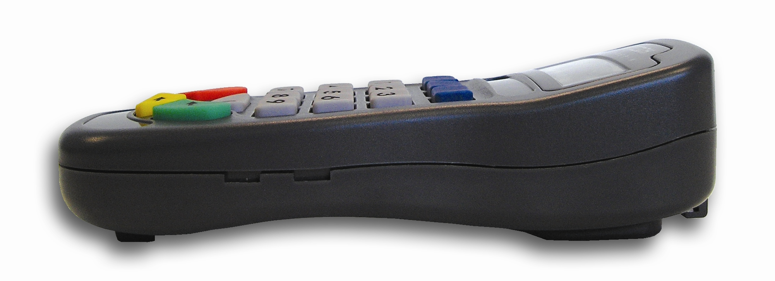
- Datasheet
- SDK (Software Development Kits) with API Manual

Promotional Activities:
- Press release
- Channel campaign
- Web page introduction
- Trade shows
- Magazine Advertisement

Warranty
ID TECH warrants to the original purchaser of SecurePIN 100 for a period of 12 months (1 year) form the date of invoice.

